Jonathan Yuan

Graduate Research Proposal

**Background**: Cancer has a major role, albeit unfortunate, in society. It is estimated that one in every six deaths is due to or related to cancer.1 Many break throughs in its treatment have been made in the past two decades ranging from surgery to radiation therapy. One area of cancer treatment that has been making headway in the last decade is targeted drug therapy.

The leading drugs for cancer treatment are platinum-based drugs (PBD) with cisplatin being the most commonly used (Figure 1). The mechanism of action of cisplatin is to first enter

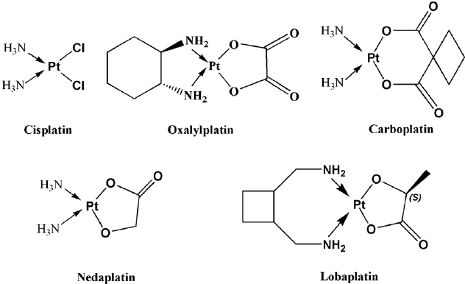a cell and replace its chloride ligands with water. The hydrolyzed complex is a very strong electrophile which then binds to two adjacent guanidine residues in the cell’s DNA.2 This linkage prevents cell division, leading to cell apoptosis.

The issues with PBDs are the route of administration and a fairly slow mechanism of action. The slow onset as well as the systemic administration of the drugs by way of IV administration causes unwanted side effects.

**Figure** **1:** Structures of cisplatin and cisplatin derivatives.

Although PBDs cause apoptosis in tumor cells, because they are not cell selective, they will cause apoptosis to cells in vital organs as well. This has a slew of toxic side effects such as hepatotoxicity, cardiotoxicity, and nephrotoxicity. In addition to side effects, cells can develop resistivity to cisplatin. Cells can increase the efflux of cisplatin, increase levels of glutathione to react with cisplatin, and cleave DNA at affected sites.3

Alternative drugs which are making headway are ruthenium-based drugs (RBD). Ruthenium forms six coordinate compounds with oxidation numbers of II, III, and IV which makes it a more flexible metal center than platinum. Ruthenium also imitates iron which binds to albumin and transferrin allowing better circulation in the body.4 The most important part about RBDs is that Ru(III) complexes are prodrugs and are inert.4 Ru(III) reduces to Ru(II), the active drug, in the hypoxic environment that tumors produce.4 As a result, RBDs are *selective* to cancer cells which is an increase in the cytotoxic effect to cancer cells and a decrease in toxic side effects.

The issue with the mechanism of action of RBDs, as well as PBDs, is the ligand exchange rate of chlorine to water. To overcome this, an electron donating ligand can be added to stabilize the resulting complex once a chlorine leaves. One such group of electron donating ligands are *N*-Heterocyclic carbenes (NHC). In addition, NHCs are fairly easy and fast to synthesize which is important in the pharmaceutical industry.

**Research Plan**: Synthesis of two standard ruthenium complexes will be done following Sullivan, Salmon, and Meyer.5 The resulting complexes, cis-Ru(bpy)2Cl2 and cis-Ru(phen)2Cl2, will be used for analysis. This will be done using commercially available starting materials and previously completed procedures.

In addition to the previously mentioned ruthenium complexes, the use of various NHCs as ligands will be employed. Because of NHCs’ easy syntheses, they can be tuned and optimized. Various Ru-NHC complexes will hypothesized and modeled using Gaussian 16 and their electronic structures will analyzed, namely the HOMO-LUMO gap. A small HOMO-LUMO gap signifies a higher reactivity, and thus a faster Cl to H2O ligand exchange rate. The NHC will not partake in ligand exchange as it has a strong bond with ruthenium due to strong σ-bonding and partial π-backbonding. Once a few Ru-NHC complexes have been selected from Gaussian modeling, they will be synthesized by adapting a procedure outlined by Grubbs.6

The ruthenium complexes will be characterized using 1H and 13C NMRs, IR, UV-Vis, emission, and most importantly CV. The cyclic voltammetry data will provide the reduction potentials for the inert Ru(III) to the active Ru(II) and the ligands. Balancing a low reduction potential for Ru(II) and a high reduction potential for the ligands will be carried out by tuning the NHC ligands.

**Intellectual Merit and Broader Impacts**: The need for alternative therapy for cancer is ever growing as more and more people are diagnosed with cancer and show resistance to commonly used treatments. Unfortunately, patients who are treated with cisplatin, commonly used for drug therapy, can develop resistance to it and have toxicological side effects due to its mechanism of action. Ruthenium based anticancer drugs show the most theoretical promise due to its selectivity to cancer cells which reduces the risk of unwanted toxicity. Even though these drugs may prove to be not as effective against certain types of cancer, they are still a tool in the growing arsenal against cancer as a whole.

**References**

1) <https://ourworldindata.org/cancer>, **2015** 2) *Eur. J. Pharmacol.* **2014** (0) 364–378. 3) *Clinics* **2018**, 73(1). 4) *Cancer Chemother Pharmacol.* **2010** 66(1), 1-9. 5) *Inorg. Chem.* **1978**, 17, 12, 3334-3341. 6) *J. Am. Chem. Soc.* 2003, 125, 9, 2546-2558.